**AVR-ISP Bread Board Adapter Rev. 0**

**Module Description**

# Introduction

The purpose of this adapter is connecting the 6 pin AVR In System Programming pin header to a bread board. There is a 6 pin box connector (2x3, 2.54mm) on top and two 3 pin (2.54mm) pin header, 600 mil apart, on the bottom side of the board. This way, it fits into a standard bread board and can be wired up with the processor. The pin header fits the AVR programmers like the Microchip Atmel-ICE, the Diamex USB ISP-Programmer (Atmel AVR) or the cheap (STK500 emulating) programmers, which are available available from AliExpress or ebay etc. for less than 10€.

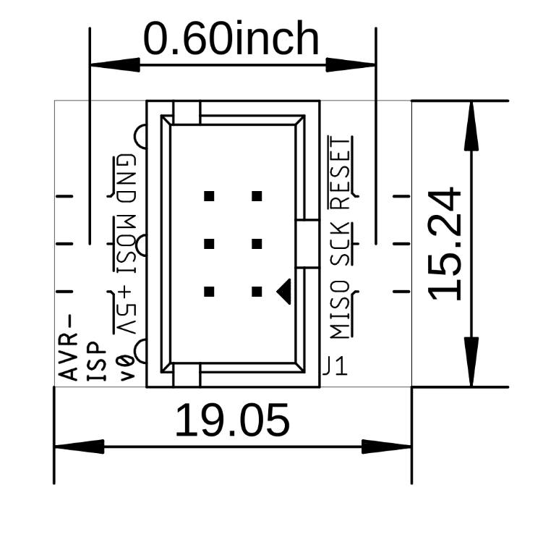

Figure 1: Dimensions of the PCB

# Connectors

|  |  |  |  |  |  |
| --- | --- | --- | --- | --- | --- |
| J2 | Signal | J1 | | Signal | J3 |
| 1 | MISO | 1 | 2 | +5V | 1 |
| 2 | SCK | 3 | 4 | MOSI | 2 |
| 3 |  | 5 | 6 | GND | 3 |

J2 and J3 are pin headers placed on the bottom side of the PCB and fit into a bread board

# Revision History

## Rev. 0

* Fully working prototype